NBA Players Data Analysis Essay

 Mamadou Dian Diallo

Emmanuel Villegas

ISMM1-UC 742 Business Intelligence

Prof. Bohdan Hawryluk

Spring 2022

Table of Contents

**Section 1: Introduction/What Determines the Best Quality of a Basketball Player?** 3

**Awareness** 3

**Desire To Get Better** 3

**Passion** 4

**Confidence** 4

**Section 2: Literature Review/What Industry are Treating Basketball Players Stats and How It Looks at Stats?** 5

**Section 2.2: The Three Steps Overview of the Process on How Analytics Works** 6

**Data Collection** 6

**Data Analysis** 7

**Application** 7

**Section 3: Data Source** 8

**Section 3.1: Why is this Data Important and To Who?** 9

**Section 4: Data Analysis** 9

**Data Selection 4.1** 9

**Data Analysis 4.2** 10

**Section 5: Findings on Dataset** 10

**Point Comparison by Year: 5.1** 10

**Assist Comparison by Year: 5.2** 15

**Rebound Comparison by Year: 5.3** 21

**Blocks Comparison by Year: 5.4** 28

**Steals Comparison by Year: 5.5** 33

**Section 6: Conclusion** 39

**Section 7: Bibliography** 40

# **Section 1: Introduction/What Determines the Best Quality of a Basketball Player?**

## **Awareness**

The best quality of Basketball players is those who can sense awareness about the game and understand that the game is not just scoring and averaging higher scores but involving their teammates to win together. On addition, there are many good basketball players that lead their team in scoring however these players struggle to bring their teams into winning games despite scoring 30, 40 plus per game. The players that have awareness and understanding of the game are much more likely to win games by just averaging low points. They do this by being active on the court on every side of the ball. For example, trusting their teammates, dishing out assists, playing great defense to stop opponents from scoring, and rebounding.

## **Desire To Get Better**

“The NBA is the best basketball league in the world.” (“NBA & MTV Social Media”) Therefore, the league has a competitive market for Teams which so creates competition between players to secure a spot a roster. This creates the necessity for players to improve their skills otherwise they will get replaced. The best quality of basketball players is the desire to get better. This is an excellent quality a player to have because willingness to get better, shows a player with ethics, work hard and is willing keep constantly working to be the best version of themselves and therefore supply more help for their team whose main goal is to win Additionally, the human brain is designed to survive. Meaning if there is no need or desire to push ourselves, we tend to become comfortable for too long at the present circumstance. This is fine for the average person. However, those who want to be ordinary and different from the rest of the people or are always competing with the best must have the hunger to better themselves otherwise they will be left behind.

## **Passion**

In similarity to the above paragraph, if a player is passionate about the sport, they will try to be successful in anyways they can. There are few basketball players in the league that really cares about basketball and does everything in their power to perform as best as they can by taking care of their body, eating, and drinking the right food, spending thousands if not millions of dollars on health to prevent scary career ending injuries. Lastly, these players train hard consistently on and off the court. Because of them being passionate about what they are doing this will make them not quit when things get difficult.

## **Confidence**

The last quality that a basketball player should have been confidence in themselves during games. If a player is skillful but not confident in games this will hurt their ability to perform at their best. We see a lot of skillful players who come into the NBA but do not stay consistent with their performance because they lack confidence. This separates the best players from average players. The best players are always active during games, playing as best as they can, and even performing better in every single game. It is true one can fall short in a few games, but confident players do not allow their past deficient performance to affect future game. So, one should be confident regardless of any distraction or opponent team.1

# **Section 2: Literature Review/What Industry are Treating Basketball Players Stats and How It Looks at Stats?**

First of what are analytics. “Oxford defines analytics as information resulting from the systematic analysis of data or statistics.” (“5 critical success factors to turn data into insight - CIO”) (“5 critical success factors to turn data into insight - CIO”) In other words, it is the outcome of analyzing different pieces of data. One of the most basic examples of analytics in sport is field goal percentage. Two different data points the number of shots taken by a player makes and the total number of shots tried by a player takes divided by each other and can get a new data point their field goal percentage. In other words, the percentage of shot attempts that were successful. Ideally, we would be able to say two players look at their field goal percentage and know which player was more efficient than the other therefore use analytics to decide who should be taking more shotes. In short, if player A shoots 50% and player B shoots 47%, we want player A to take more shots.

This analysis only works if they are taking the exact shots from the same part of the floor, against the same defender, the same at the same point during the game. This also assumes that they have the same height, weight, play the same position and have the exact same play called for them. The goal of analytics is to take all these variables and figure out how to make them equal so that people can make decisions like which players should and should not be on the floor. Not only can a team make decisions on who should play, they can also analyze player health, efficiency, lineups and even stuff like ticket sales or what adds to show in the arena.

## **Section 2.2: The Three Steps Overview of the Process on How Analytics Works**

An overview of how this process works and some of the business how teams collect this data use this data and, in some cases, buy or sell this data. Here is an oversimplified of the analytics process split into three phases.

### **Data Collection**

The first is Data Collection. Which is the process of collecting data like the number of shots a player has taken, shots made, point, rebound, assists and other essential stats that help us have a better understanding of the player’s performance. These are easy to count and quantify and are called counting stats because we just count the amount of time these numbers occurred in a game. Then there is a second more complex set of data points that teams use.

For example, in 2009 the NBA started installing motion capturing cameras in every arena in the league. The goal for this was to start collecting data from movement and in effort to allow teams to use this data to perform better more comprehensive analysis on their players. They looked to create a version of the game that could be understood and analyzed by computers and up to whoever has access to this data to make sense of it. This was also a subtle business move on behalf of the league where they also made this data available to third parties at an inflated cost of millions of dollars. Sometimes we also see players in vest or technology suit, and these body suits add more accuracy, motion capture data, have both GPS, and heart rate monitors to help track stuff like athlete performance and health. These are just some examples of how teams collect data on their players. Once collected, data is then used to train models to look for different things using machine learning.

### **Data Analysis**

Once data is collected, we move into the second phase which is Data Analysis. In this step we have the data now we try and make sense of it and how we can use this information we collected to find some new piece of information which can be used to decide the choosing of a more efficient player for a team. It used to be the case that much of this analysis was performed exclusively in-house by each team which is very much the case but there are companies that looked at removing much of the burden for sports teams by performing lot of the basic analysis that teams would otherwise be burdened with doing on their own. One of these companies is Second Spectrum, a company partially funded by clippers owner Steve Ballmer. Second Spectrum, who is the official tracking and analytics partner for leagues such as the NBA and MLS, work with these leagues and other sports companies to provide them with a few different solutions. One of their main offerings is instant breakdown and analysis using a suite machine learning video indexing or machine learning models to help teams instantly conduct analysis soon as they upload film of their game. It will output basic stats like counting stats point, assist, rebounds, steals, and blocks. It will also provide more in-depth analysis of like which plays will run, short selection, possession, number of crosses and other important statistics that provides analyst with a deeper understanding of the subject.

### **Application**

The next phase after completing the analysis is application where we apply the analysis to the real world such as setting our lineups to favor the more efficient shooter. The first way data is applied is through broadcast. Second Spectrum’s capabilities unlock cool features which is their augmented reality streams showing stuff like animations real time players, shot probability, name under the player. It takes all this data that is outputted by the program, and it creates real world animation showing this analysis in real time. The second way this data is applied is at the time of making crucial decision by team’s front office and to think of when we hear about analytics. This is where teams use data from second spectrum as well as other sources like players are wearing other tracking data and counting stats to begin making decisions about who should be playing, when they should be playing and whether they should rest their players. This type of analysis is usually performed exclusively by the analytics department within each team.

For example, all 30 teams in the NBA have an analytics department. Though some are more invested in it than others. These commonly include some combination of data scientists, engineers, and directors. The size of the analytics department is between two to nine members. There is no correlation between performance and the size of a team analytics department. Some teams have started outsourcing their analytics department or at least partnering with a third-party firm to conduct some of their analysis. One of these firms is Zealous analytics. They help teams make decisions by performing more analysis and using proprietary models to help the teams they partner with gain competitive advantage while also significantly lowering their costs.

The last application is on gambling. It is how sports books and apps like fan duel and DraftKings can calculate their odds predict over under and assign values to different players based on their respective matchup’s.

# **Section 3: Data Source**

  In this research paper, we will be analyzing and interpreting a dataset that holds information about Basketball players from different leagues around the world. The dataset includes seasons from 1999 to 2020 with 49 leagues and over 11,000 players information details & their stats per season. Player details information include their birth date, height, weight, and nationality. Stats per season columns are scoring stats, free throws, rebounds, blocks, assists, minute, games etc. The dataset comes from a website called Kaggle and data is scraped from real basketball general managers.2

In this case, we will be focusing on the National Basketball Association (NBA). The goal with this project is to find out patterns that are predictable between players. By finding this information we will be able to supply predictions and therefore have valuable information about players. This type of information will help us figure out and execute business decisions at the time of signing players. We will decide with the information obtained from our research the best quality of basketball players by deeply analyzing their careers and comparing them with other players.

## **Section 3.1: Why is this Data Important and To Who?**

The National Basketball League (NBA) is the most competitive basketball league in the world. Therefore, it is where the best basketball players set their legacies. The NBA generates billions in revenue each year. Indeed, the “League commissioner Adam Silver projects $10 billion in *revenue*.” so this league produces a lot of cash flows.  The average salary for players is “around $7.5 million” with 30 teams and a maximum of 15 players in a team that comes to 450 players annually. The NBA highest pay player makes “$45,780,966” a season.3

# **Section 4: Data Analysis**

## **Data Selection 4.1**

There was little to no cleaning on our dataset because it was already organized, so we decided to move to the next phase by selecting the data we need to conduct our research. We decided to focus on the regular season player stats because that is where most players are active during the NBA season. Also, not everyone can make the playoffs, so it was not right to select data from the playoff or any other levels that is not the regular season.

## **Data Analysis 4.2**

The next step is to understand this data. Using data mining and Excel to create pivot tables and add filters to answer questions such as what players had at least five plus seasons and the total of top 100 players in points made during their career. With this information it is possible to find out who has played the longest season, highest total point, assist, rebounds, steals and blocks. It helps to find trends in the data which helps to create percentages of these increases or decreases throughout the career of players.

# **Section 5: Findings on Dataset**

## **Point Comparison by Year: 5.1**

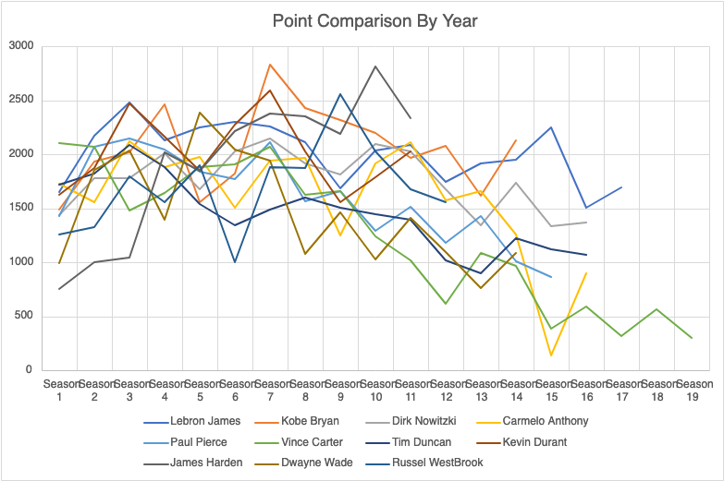

**Chart 5.1**

Chart 5.1 shows that 11 players selected from this dataset show interesting patterns in the players' careers. After analyzing players' careers year by year and comparing them with other top-level players it helps to understand NBA players and their declines and increases in performance over the years. It shows a decline in years 8-9 of players' careers.

Chart 5.1 shows that 72% of players declined by 20% or more and only 28% an increase of 25% or more after season 8. The data show the case of Lebron James who went from 2,111 in season 8 to 1,683 to season 9 meaning a 20% decline in performance. Now, this could be justified have been caused by the switching of teams after his Most Valuable Season in year 8. Indeed, 100% of the players picked in this analysis that went on to switched teams had drastic declines on their performance the season after switching teams. Furthermore, the data shows that in the case of Carmelo Anthony, he dropped 36% from 1,970 points to 1,245 in season 8 compared to his season in where he had a solid year with 1,943. Again, the drop in points could also be attributed to the fact that Carmelo switched teams in season 10. Another case the data shows the case of Kevin Durant. In season 8 Durant dropped 23% from 2,029 points to 1,555 points in season 9 in where Durant switch teams in season 9. However, the data shows some some outliers on this data in where 2 players increase their percentage of points in season 8. In the case of Dwayne Wade, it increases 25% in season 9. He went from Season 8, from 1,082 to 1,463 points in Season 9. In the case of Russel Westbrook increases 26% in points. He went from 1,878 points to 2,558 points in Season 9.

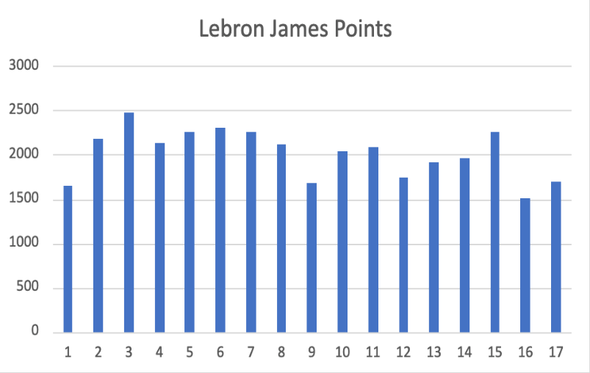

**Chart 5.1.1**

Chart 5.1.1 shows visualization of data points by Lebron James, he dropped 20% from 2,111 on season 8 compared to 1,683 on season 9.

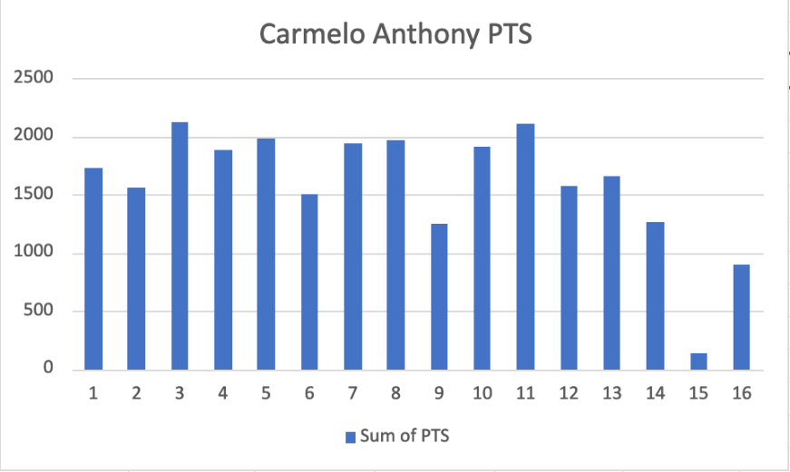

**Chart 5.1.2**

Chart 5.1.2 shows visualization of data points by Carmelo Anthony, he dropped 36% from 1,970 points to 1,245 in his season 8 compared to his season 9 in where he had a solid year with 1,943 points.

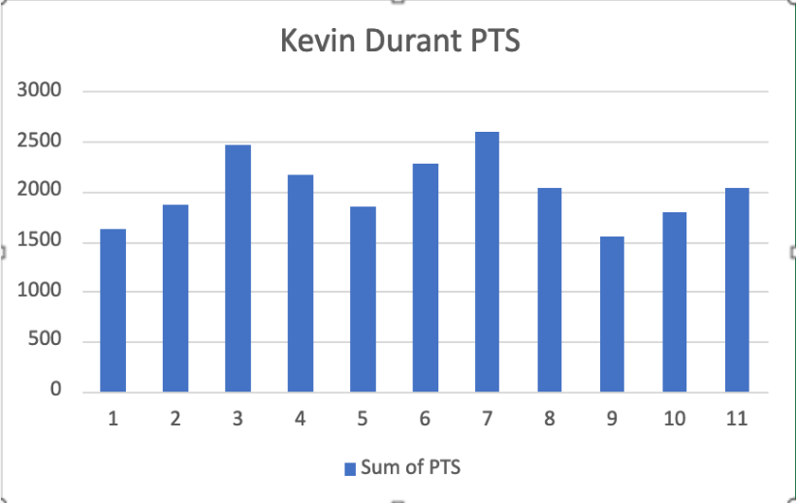

**Chart 5.1.3**

Chart 5.1.3 shows visualization of data points by Kevin Durant. In season 8 Durant dropped 23% from 2,029 points to 1,555 points in season 9 in where Durant switch teams in season 9.

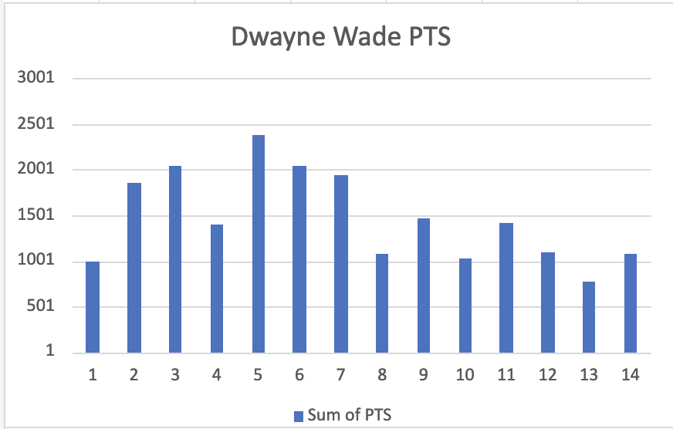

**Chart 5.1.4**

Chart 5.1.4 shows visualization of data points by Dwayne Wade, he increased 25% in season 9. He went from Season 8, from 1,082 to 1,463 points in Season 9.

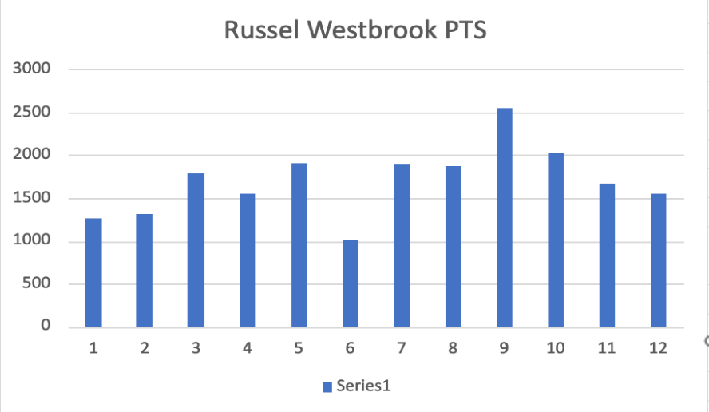

**Chart 5.1.5**

Chart 5.1.5 shows visualization of data points by Russel Westbrook increases 26% in points. He went from 1,878 points to 2,558 points in Season 9.

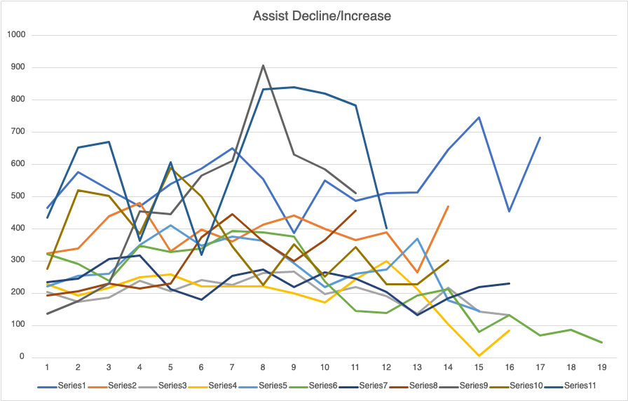

## **Assist Comparison by Year: 5.2**

The following chart 5.2 shows data visualization of a combination of 11 players where the trends in their distribution of assists ratio can be seen. It shows interesting facts about the players from season 8 to their 9th season.

The assist data shows a diverse set of variation between their peak of their biggest number of assist and the year of the second highest. The data shows that 72% of players show a decline in their assists after season 9. It shows that out of 11 players selected 27% peaked in season 9. In addition, 27% of players peaked in season 7 and 27% of players peaked in season 5.

Again, the data shows a drop in stats in this case the number of assists distributed in from season 8 to season 9. The data shows that Lebron James, Carmelo Anthony and Kevin Durant had a significant drop in their percentage of assists. With 30%, 16% and 9% respectively. The reason for this drop again would be the fact that these 3 players played for different teams in their 9th season. However, the data shows some decreases in assists on other players that do not share the same factor as the 3 earlier players. Paul Pierce dropped 19% from season 8 to season 9. Also, the data shows that James Harden had a 30% drop from season 8 to season 9. Furthermore, the data shows that Tim Duncan had a 20% drop from season 8 to season 9. The data shows that Vince Carter had a 3.3% drop from season 8 to season 9. On the other hand, the data shows some outliers to the decreasing trend on from season 8 to season 9. Although, these outliers are slightly less severe than the decreases. The data shows that Dwayne Wade had a slight increase of 36% in assist distribution from season 8 to season 9. The data shows that Kobe Bryant had a slight increase of 6% in assist distribution from season 8 to season 9 where he had his highest number of assists distributed over his 14 total seasons played. The data shows that Dirk Nowitzki had a slight increase of 1% in assist distribution from season 8 to season 9 which was also his highest during his 16 seasons playing in the NBA.

The data shows that 63% of players declined in season 9 and only 27% were able to bounce back and get their assist production higher on their next season, season 10. Lebron James and Kevin Durant were able to have a total of 551 and 366 assists on their 10th season, respectively. Furthermore, Durant went on to have his best season in assists in his 11th season with 457. This was not the case for Lebron James where he had another 11% in assist ratio. The data shows that 2 of these 3 players that had already switched teams on their season 9 were able to get their assist production to where it was in their season 8. The other player, Carmelo Anthony continued to decline in his 10th season with 14% decline in assists but was able to recover in his 11th season with a 30% increase and on season 12th he was able to have an assist career high year with 299 assists. The last player on this list is Tim Duncan who was able to increase his production on season 10th with a 17% increase.

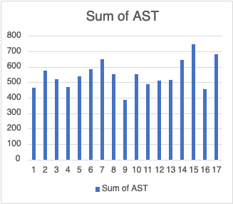

**Chart 5.2.1**

Chart 5.2.1 shows visualization of data Assist by Lebron James decreased 30% in assist. He went from 554 assists on season 8 to 387 assists in Season 9. And, how he was able to bounce back on season 10th.

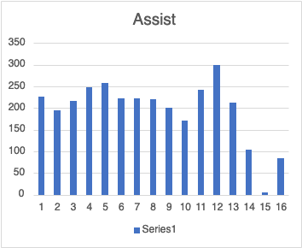

**Chart 5.2.2**

Chart 5.2.2 shows visualization of data Assist by Carmelo Anthony decreased 16% in assists. He went from 221 assists on season 8 to 200 assists in Season 9. Anthony kept decreasing until he was able to bounce back on season 11th and on season 12th, he was able to have his highest assisting season.

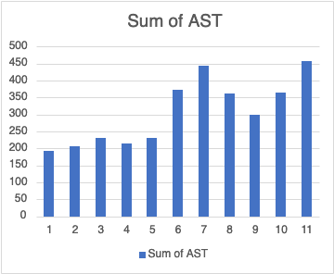

**Chart 5.2.3**

Chart 5.2.3 shows visualization of data Assists by Kevin Durant decreased 9% in assists. He went from 361 assists on season 8 to 300 assists in Season 9. We can see how he was able to bounce back in season 10 and in season 11 he had his highest assisting season. 

**Chart 5.2.4**

Chart 5.2.4 shows visualization of data Assists by Paul Pierce decreased 19% in assists. He went from 363 assists on season 8 to 294 assists in Season 9. 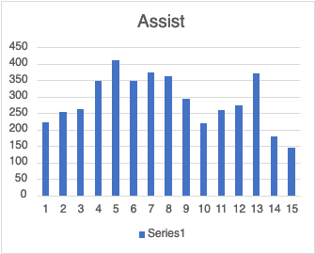

**Chart 5.2.5**

Chart 5.2.5 shows visualization of data Assists by James Harden 30% in assists. He went from 907 assists in season 8 to 630 assists in Season 9. 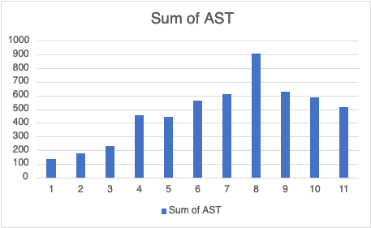

**Chart 5.2.6**

Chart 5.2.6 shows visualization of data Assist s by Tim Duncan with 20% decrease in assists. He went from 273 assists in season 8 to 218 assists in Season 9.

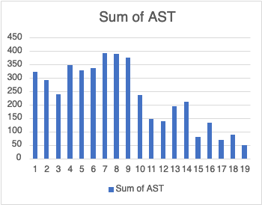

**Chart 5.2.7**

Chart 5.2.7 shows visualization of data Assists by Vince Carter 3.3% decreased in assists. He went from 389 assists in season 8 to 376 assists in Season 9. 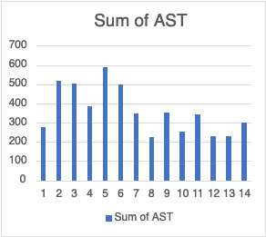

**Chart 5.2.8**

Chart 5.2.8 shows visualization of data Assists by Dwayne Wade 36% increase in assists. He went from 225 assists in season 8 to 352 assists in Season 9. 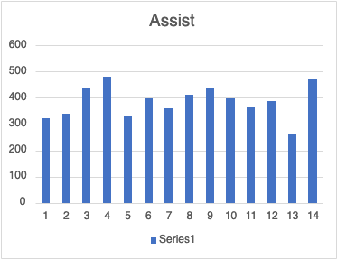

**Chart 5.2.9**

Chart 5.2.9 shows visualization of data Assists by Kobe Bryant 6% increase in assists. He went from 413 assists in season 8 to 441 assists in Season 9 where he had his highest number of assists distributed over his 14 total seasons played. 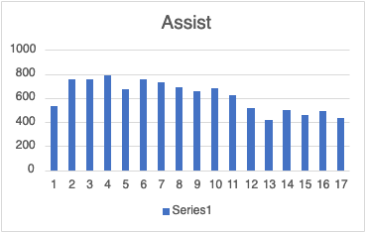

**Chart 5.2.10**

Chart 5.2.10 shows visualization of data Assists by Dirk Nowitzki 1% increase in assists. He went from 263 assists in season 8 to 266 assists in Season 9 which was his highest during his 16 seasons playing in the NBA.

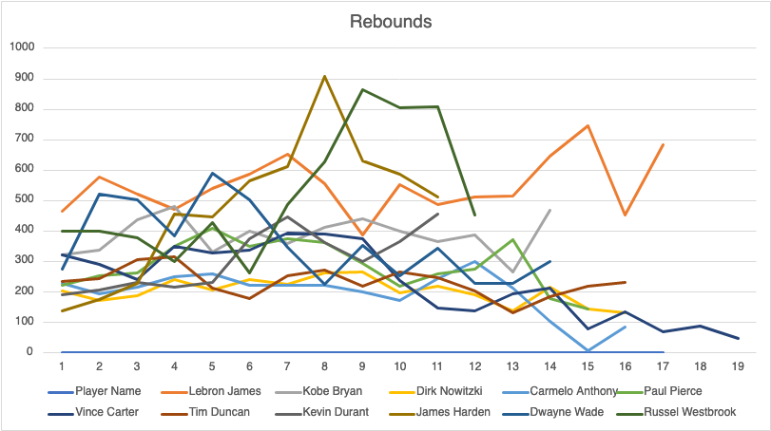

**Rebound Comparison by Year: 5.3**

The following chart 5.3 shows the visualization of a combination of 11 players where we can see the trends in their distribution of rebounds ratio. It shows some patterns in the players' 9th season. It shows that 63% of players decline in their rebounding after season 9. While 18% of them had their best rebounding season after season 9 and went to have a declining next season. The remaining 18% of players had a slight increase on season 9 in rebounding compared to their earlier season.

The rebounds data shows a diverse set of variations between their peak of their biggest number of rebounds. It shows patterns in the players' 9th season. It shows that 63% of players show declines in their rebounding. Lebron James had a 30% decline in season 9, he went from 554 rebounds on season 8 to 387 rebounds on season 9 which also, was the season he switched teams. Dirk Nowitzki had a 25% decline in season 9, he went from 266 rebounds on season 8 to 197 rebounds on season 9. Carmelo Anthony had a 14% decline in season 9, he went from 200 rebounds on season 8 to 171 rebounds on season 9. Paul Pierce had a 26% decline in season 9, he went from 294 rebounds on season 8 to 218 rebounds on season 9. Tim Duncan had a 20% decline in season 9, he went from 273 rebounds on season 8 to 218 rebounds on season 9. Tim Duncan had a 16% decline in season 9, he went from 361 rebounds on season 8 to 300 rebounds on season 9. James Harden had a 30% decline in season 9, he went from 907 rebounds on season 8 to 630 rebounds on season 9.

On the other hand, the data shows 27% of outliers. Kobe Bryant had a 6% increase in season 9, he went from 413 rebounds on season 8 to 441 rebounds on season 9. Dwayne Wade had a 36% increase in season 9, he went from 225 rebounds on season 8 to 352 rebounds on season 9. Russel Westbrook had a 24% increase in season 9, he went from 626 rebounds on season 8 to 864 rebounds on season 9 which was his best rebounding season.

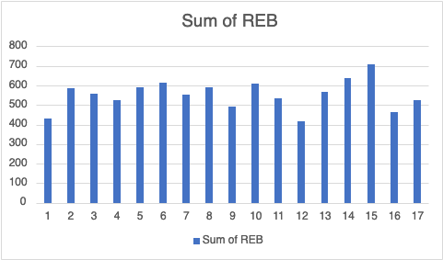

**Chart 5.3.1**

Chart 5.3.1 shows visualization of data Rebounds by Lebron James, he had a 30% decline in season 9, he went from 554 rebounds on season 8 to 387 rebounds on season 9.

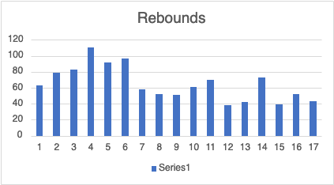

**Chart 5.3.2**

Chart 5.3.2 shows visualization of data Rebounds by Dirk Nowitzki, he had a 25% decline in season 9, he went from 266 rebounds on season 8 to 197 rebounds on season 9.

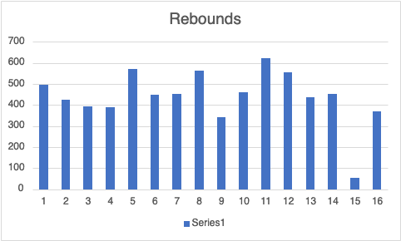

**Chart 5.3.3**

Chart 5.3.3 shows visualization of data Rebounds by Carmelo Anthony, he had a 14% decline in season 9, he went from 200 rebounds on season 8 to 171 rebounds on season 9.



**Chart 5.3.4**

Chart 5.3.4 shows visualization of data Rebounds by Paul Pierce, he had a 26% decline in season 9, he went from 294 rebounds on season 8 to 218 rebounds on season 9.

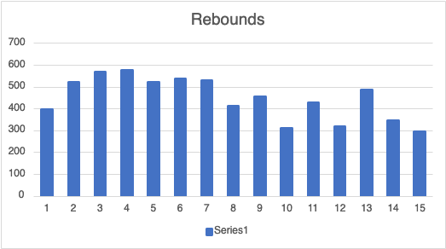

**Chart 5.3.5**

Chart 5.3.5 shows visualization of data Rebounds by Tim Duncan, he had a 20% decline in season 9, he went from 273 rebounds on season 8 to 218 rebounds on season 9.

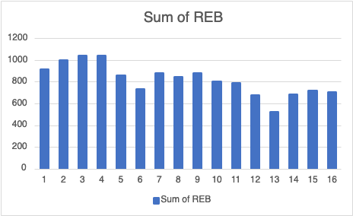

**Chart 5.3.6**

Chart 5.3.6 shows visualization of data Rebounds by James Harden, he had a 30% decline in season 9, he went from 907 rebounds on season 8 to 630 rebounds on season 9.



**Chart 5.3.7**

Chart 5.3.7 shows visualization of data Rebounds by Kobe Bryant, he had a 6% increase in season 9, he went from 413 rebounds on season 8 to 441 rebounds on season 9.

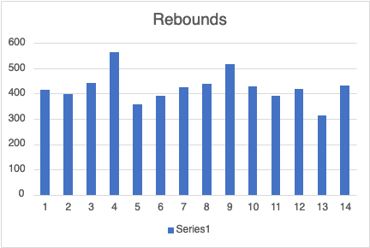

**Chart 5.3.8**

Chart 5.3.8 shows visualization of data Rebounds by Dwayne Wade, he had a 36% increase in season 9, he went from 225 rebounds on season 8 to 352 rebounds on season 9.

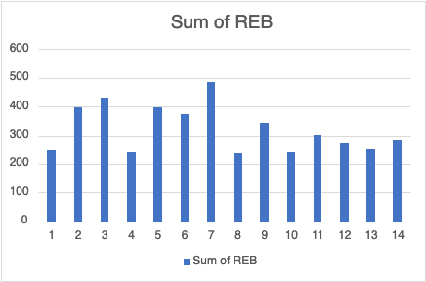

**Chart 5.3.9**

Chart 5.3.9 shows visualization of data Rebounds by Russel Westbrook had a 24% increase in season 9, he went from 626 rebounds on season 8 to 864 rebounds on season 9, which was his best rebounding season.

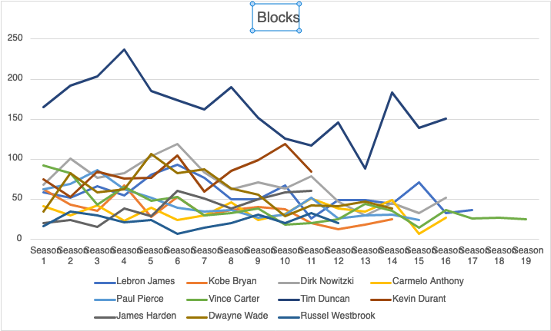

## **Blocks Comparison by Year: 5.4**

The Blocks data shows some interesting patterns also in players' first 6 seasons. It shows that 81% of players show declines in their rebounding after season 6. 27% of players started to decline in season 3. 9% on season 4. 18% of players on season 5 and 18% of players on season 5 and 6. It also shows 18% of players are outliers.

The Blocks data shows some interesting patterns also in players' first 6 seasons. It shows that Paul Pierce declined 27% in rebounding from season 3 with 86 rebounds to season 4 with only 62 rebounds. It shows that Vince Carter declined 10% after his 1st season with 92 rebounds to his 2nd season with 82 rebounds following a 47% decline on his third season with only 43 rebounds. Furthermore, he went on to keep declining throughout the remaining season in his career. It shows that Kobe Bryant and Tim Duncan dropped 58% and 21% respectively from their 4th season into their 5th season. It shows that Dwayne Wade dropped 22% from their 5th season into his 6th season. It shows that Lebron James, Dirk Nowitzki and James Harden dropped 17%, 30% and 15% respectively from their 6th season into their 7th season. It shows 18% outliers with Carmelo Anthony having his best blocking season on his 11th season with 51 blocks and Kevin Durant on his 10th season with 119 blocks.

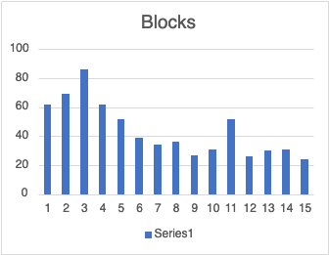

**Chart 5.4.1**

Chart 5.4.1 shows visualization of data blocks by Paul Pierce, it shows a 27% decline in rebounding from season 3 with 86 rebounds to season 4 with only 62 rebounds.

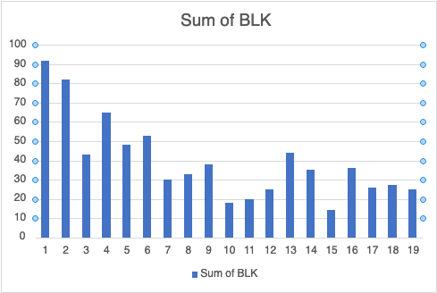

**Chart 5.4.2**

Chart 5.4.2 shows visualization of data Blocks by Vince Carter, it shows a 10% decline after his 1st season with 92 rebounds to his 2nd season with 82 rebounds following a 47% decline on his third season with only 43 rebounds.

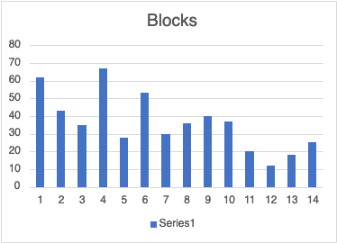

**Chart 5.4.3**

Chart 5.4.3 shows visualization of data Blocks by Kobe Bryant, it shows a 58% decline after his 4th season with 67 rebounds to his 5th season with 28 rebounds.

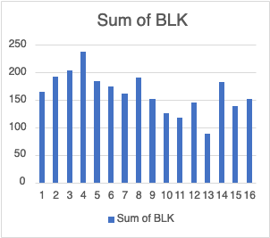

**Chart 5.4.4**

Chart 5.4.4 shows visualization of data Blocks by Tim Duncan, it shows a 21% decline after his 4th season with 237 rebounds to his 5th season with 185 rebounds.



**Chart 5.4.5**

Chart 5.4.5 shows visualization of data Blocks by Dwayne Wade, it shows a 22% decline after his 5th season with 106 rebounds to his 6th season with 82 rebounds.



**Chart 5.4.6**

Chart 5.4.6 shows visualization of data Blocks by Lebron James. It shows a 17% decline after his 6th season with 93 rebounds to his 7th season with 77 rebounds. 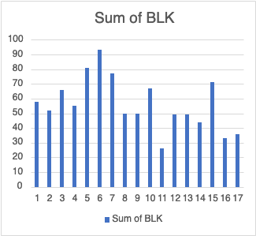

**Chart 5.4.7**

Chart 5.4.7 shows visualization of data Blocks by Dirk Nowitzki, it shows a 30% decline after his 6th season with 119 rebounds to his 7th season with 83 rebounds.

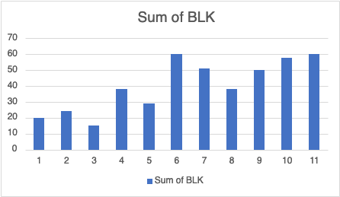

**Chart 5.4.8**

Chart 5.4.8 shows visualization of data Blocks by James Harden, it shows a 15% decline after his 6th season with 60 rebounds to his 7th season with 51 rebounds. 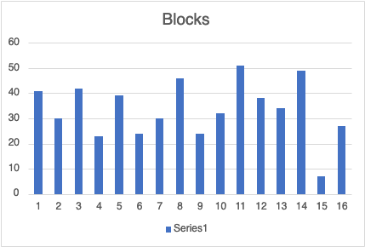

**Chart 5.4.9**

Chart 5.4.9 shows visualization of data Blocks by Carmelo Anthony, it shows a 37% increase after his 10th season with 32 rebounds to his 11th season with 51 rebounds.

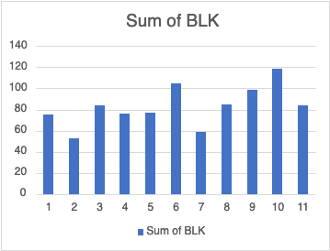

**Chart 5.4.10**

Chart 5.4.10 shows visualization of data Blocks by Kevin Durant, it shows a 16% increase after his 9th season with 99 rebounds to his 10th season with 119 rebounds.

## **Steals Comparison by Year: 5.5**



The Steals data shows some interesting patterns also in players firsts 6 seasons. It shows that 72% of players show declines in their rebounding after season 6. 27% of players started to decline in season 3. 9% after season 4. 18% of players started to decline after season 5 and 36% of players after season 5 and 6.

The Steals data shows some interesting patterns also in players firsts 6 seasons. Lebron James had a 30% decline from 177 steals on season 3 to 123 steals on season 4. Tim Duncan had a 17% decline from 70 steals on season 3 to 61 steals on season 4. Vince Carter had a 17% decline from 114 steals on season 5 to 94 steals on season 6. Kobe Bryant had a 38% decline from 181 steals on season 5 to 112 steals on season 6. Dirk Nowitzki had a 17% decline from 111 steals on season 5 to 92 steals on season 6. Dwayne Wade had a 17% decline from 173 steals on season 5 to 142 steals on season 6 and then another 21% and 26% decline on season 7 and season 8 with 111 and 82 steals, respectively. In the case of Russel Westbrook had 155 steals on season 5 and a 27% decline with 112 steals on season 6. We can visualize this on the following graph.

There were only 2 players of the 11 analyze to peak in steals after season 6. Kevin Durant had 116 steals on season 7 and an 11% and 33% decline on season 8 and season 9 with 103 and 69 steals, respectively. James Harden had 158 steals on season 11 and a 20% decline on season 10 with 125 steals.

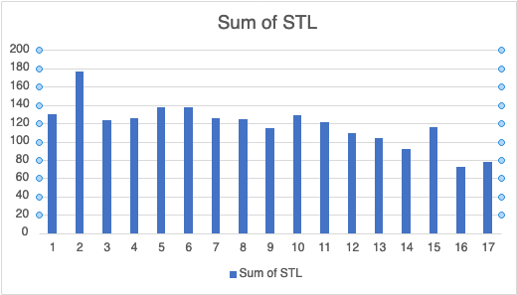

**Chart 5.5.1**

Chart 5.5.1 shows visualization of data Steals by Lebron James had a 30% decline from 177 steals on season 3 to 123 steals on season 4.

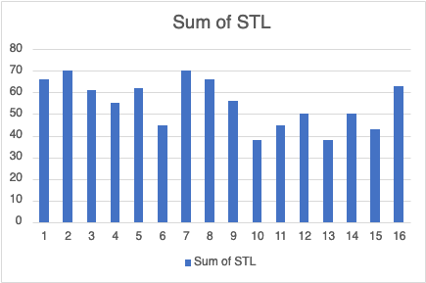

**Chart 5.5.2**

Chart 5.5.2 shows visualization of data Steals by Tim Duncan had a 17% decline from 70 steals on season 3 to 61 steals on season 4.

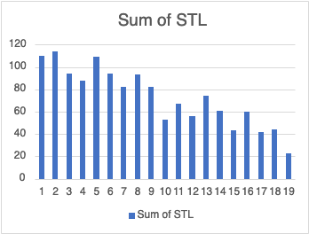

**Chart 5.5.3**

Chart 5.5.3 shows visualization of data Steals by Vince Carter had a 17% decline from 114 steals on season 5 to 94 steals on season 6.

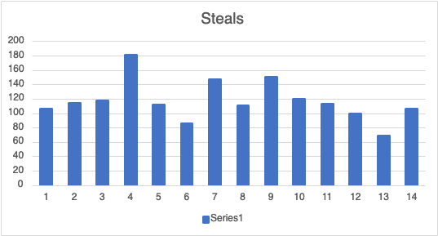

**Chart 5.5.4**

Chart 5.5.4 shows visualization of data Steals by Kobe Bryant had a 38% decline from 181 steals on season 5 to 112 steals on season 6.

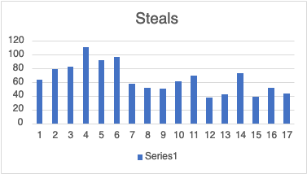

**Chart 5.5.5**

Chart 5.5.5 shows visualization of data Steals by Dirk Nowitzki had a 17% decline from 111 steals on season 5 to 92 steals on season 6.

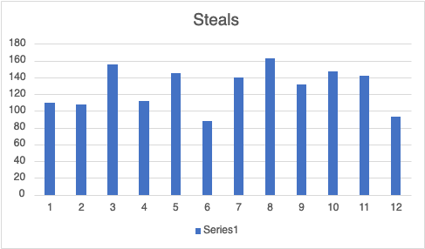

**Chart 5.5.6**

Chart 5.5.6 shows visualization of data Steals by Russel Westbrook had 155 steals on season 5 and a 27% decline with 112 steals on season 6.

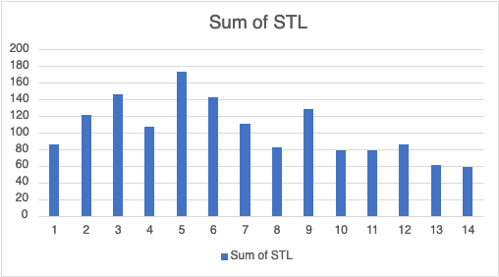

**Chart 5.5.7**

Chart 5.5.7 shows visualization of data Steals by Dwayne Wade had a 17% decline from 173 steals on season 5 to 142 steals on season 6 and then another 21% and 26% decline on season 7 and season 8 with 111 and 82 steals, respectively.

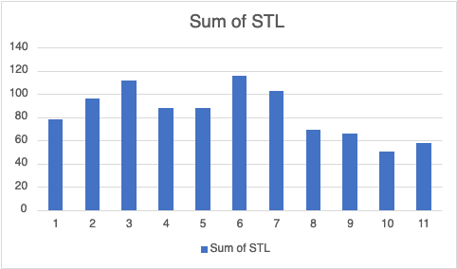

**Chart 5.5.8**

Chart 5.5.8 shows visualization of data Steals by Kevin Durant, he had 116 steals on season 7 and an 11% and 33% decline on season 8 and season 9 with 103 and 69 steals, respectively.

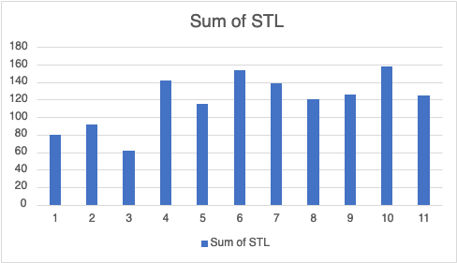

**Chart 5.5.9**

Chart 5.5.9 shows visualization of data Steals by James Harden had 158 steals on season 11 and a 20% decline on season 10 with 125 steals.

# **Section 6: Conclusion**

The data concludes that after Season 9 it is expected that there will be a decline in players offense since their scoring, assists and rebounds production will progressively decline. It shows that 72% of players declined by 20% or more and only 28% an increase of 25% or more after season 8. The data shows that 63% of players declined in season 9. The data shows that 63% of players decline in their rebounding after season 9. The data shows that 72% of players show declines in their rebounding after season 6. The data shows that 81% of players show declines in their steals after season 6. Also, the data helps to predict that players will have a steady decline in their defensive effectiveness after playing 6 seasons because their blocks and steals number will drop after their first seasons.

# **Section 7: Bibliography**

1. 2Baruch, J. (2020, November 24). *Basketball players' stats per season - 49 leagues*. Kaggle. Retrieved May 3, 2022, from <https://www.kaggle.com/datasets/jacobbaruch/basketball-players-stats-per-season-49-leagues>
2. 1CoachUp. (2014, October 14). *10 qualities that make a basketball player great*. Coach Up Nation. Retrieved May 3, 2022, from <https://www.coachup.com/nation/articles/10-qualities-that-make-a-basketball-player-great>
3. 3Scottfujita. (2022, February 26). *How much do NBA players make on average?* Scott Fujita. Retrieved May 3, 2022, from <https://www.scottfujita.com/how-much-do-nba-players-make/>